Lydia Samuel

Week 9 SQL Homework

08-10-2019

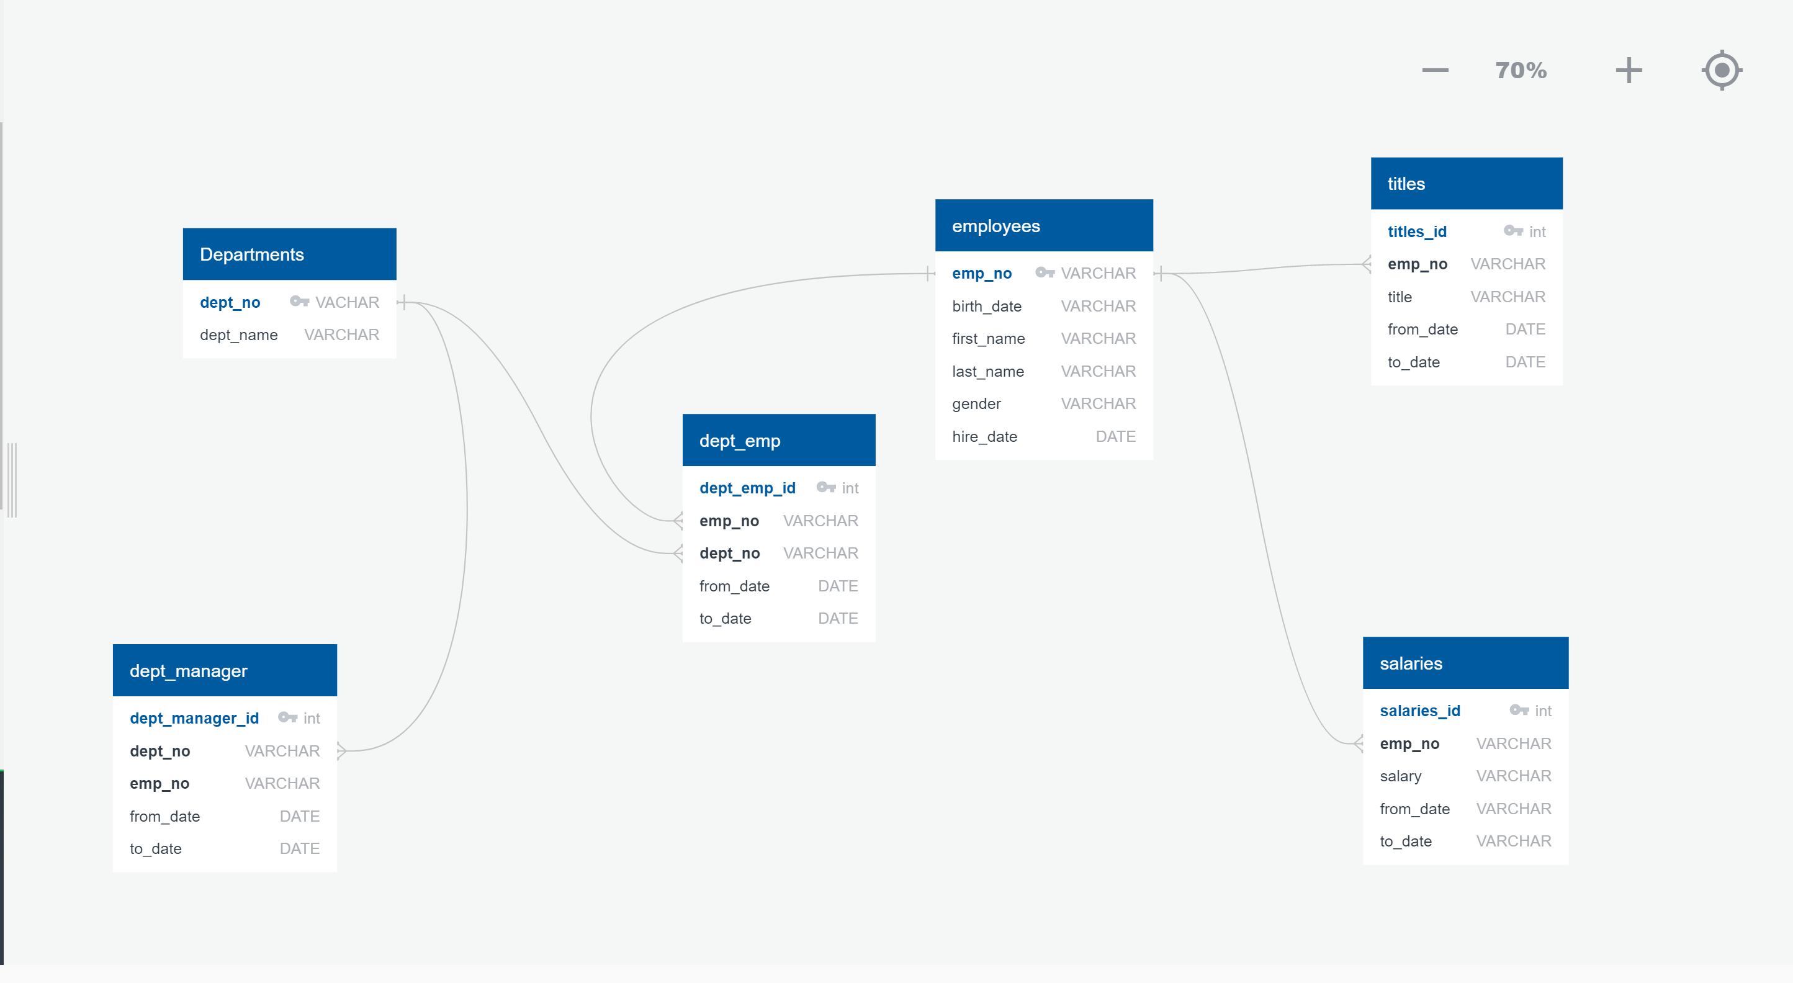

1. List the following details of each employee: employee number, last name, first name, gender, and salary.

SELECT e.emp_no,

e.last_name,

e.first_name,

e.gender,

s.salary

FROM employees e

JOIN

salaries s

ON

e.emp_no= s.emp_no;

2.List employees who were hired in 1986.

SELECT first_name,

last_name,

hire_date

FROM employees

WHERE TO_CHAR(hire_date, 'yyyy')= '1986';

3. List the manager of each department with the following information: department number, department name,

the manager's employee number, last name, first name, and start and end employment dates.

SELECT dm.dept_no,

d.dept_name,

dm.emp_no,

e.last_name,

e.first_name,

dm.from_date,

dm.to_date

FROM employees e

JOIN

dept_manager dm

ON

e.emp_no= dm.emp_no

JOIN departments d

ON

dm.dept_no= d.dept_no;

4.List the department of each employee with the following information: employee number, last name, first name, and department name.

SELECT e.emp_no,

e.last_name,

e.first_name,

d.dept_name

FROM employees e

JOIN

dept_emp de

ON

e.emp_no= de.emp_no

JOIN

departments d

ON

d.dept_no= de.dept_no;

5.List all employees whose first name is "Hercules" and last names begin with "B."

SELECT *

FROM employees e

WHERE first_name= 'Hercules'

AND last_name LIKE 'B%'

6.List all employees in the Sales department, including their employee number, last name, first name, and department name.

SELECT e.emp_no,

e.last_name,

e.first_name,

d.dept_name

FROM employees e

JOIN

dept_emp de

ON

e.emp_no= de.emp_no

JOIN

departments d

ON

d.dept_no= de.dept_no

WHERE d.dept_name = 'Sales';

7.List all employees in the Sales and Development departments, including their employee number, last name, first name, and department name.

SELECT e.emp_no,

e.last_name,

e.first_name,

d.dept_name

FROM employees e

JOIN

dept_emp de

ON

e.emp_no= de.emp_no

JOIN

departments d

ON

d.dept_no= de.dept_no

WHERE d.dept_name = 'Sales'

OR d.dept_name= 'Development';

8.In descending order, list the frequency count of employee last names, i.e., how many employees share each last name.

SELECT last_name,

COUNT(*)

FROM employees

GROUP BY last_name

ORDER BY last_name DESC;